Albuquerque City Women’s Golf Championship
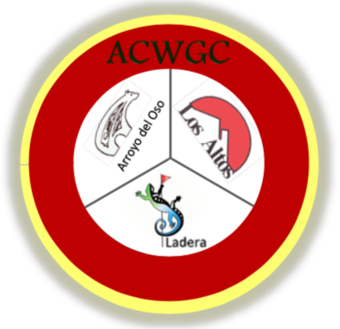
October 12-14, 2021
Los Altos Golf Course—October 12
Arroyo del Oso Golf Course—October 13
Ladera Golf Course—October 14

Entry Fee Categories per Player:
3-day Regular Green Fee - $140
3-day Senior Green Fee (55+) - $125
3-day Junior Green Fee (17 and under) - $110
3-day City of Albuquerque Municipal Golf Course Annual Pass Holder or Lifetime Pass Holder - $85
2-day Senior (70+)/Super Senior (75+) Green Fee (Tuesday, Oct. 12 & Thursday, Oct. 14 only) - $110
2-day Senior (70+)/Super Senior (75+) Green Fee with Alb. Municipal Annual Pass or Lifetime Pass - $85
GENERAL INFORMATION:
- Open to all NM resident, amateur women golfers who have a USGA Handicap Index
- Field limited to the first 120 players to register
- The maximum handicap to which a competitor can compete is 40.4 per USGA Guidelines
- Entry fee includes green fees, tee gift, awards and luncheon
- Carts are not required and are not included in entry fee. Cart fees and range balls may be paid for separately at the respective golf course(s) on the day of play
- NM resident caddies may be used pursuant to USGA Guidelines
- 3 days of 18-hole stroke play, October 12-14, with flights (*except for Senior & Super Senior Flights)
- Flights will be determined by Handicap Index
- *Senior and Super Senior Flights are open to NM resident, amateur women golfers who have a USGA Handicap Index and are at least 70 & 75, respectively, years of age as of September 1, 2021. Two days of 18-hole stroke play-Oct. 12 at Los Altos Golf Course and Oct. 14 at Ladera Golf Course
- Awards luncheon will be held after play at Ladera Golf Course (banquet room)

STARTING TIME—8:30 Shot Gun Start
ENTRIES:
- Entry fees are subject to qualification categories
- Checks must be submitted with entry form (no cash, please)
- Entry Deadline: September 24, 2021. Refunds ARE NOT available for withdrawals after the deadline
- Make checks payable to LAWGA and mail with the attached entry form to:
LAWGA – ACWGC
c/o Kathleen Rael
6327 Cliffbrush Ln NE
Albuquerque, NM 87111
Questions can be directed to Karla DeGroft at kdegroft@gmail.com or 505-259-2073
Tee times for practice rounds can be made by calling the pro shops:
Los Altos Golf Course—505-298-1897
Arroyo del Oso Golf Course—505-884-7505
Ladera Golf Course—505-836-4449

